Installation Guide

**Getting Started**

GitHub repository: <https://github.com/t-brunson/Rally-WDC>

Download Node JS <https://nodejs.org/en/download/>

Once you have node installed you can install the project on your machine

**Step: 1**

Download all the files from the git repository and save them where you want to run the server from.

For this example let’s say we save the files on the desktop

**Running the server**

Open command prompt and go to where you saved the Rally-WDC folder

For me the code would be

cd Desktop

cd Rally-WDC-master

cd Rally-WDC-master

Next install all the required modules for the project to run you do this by running **npm install**

npm install

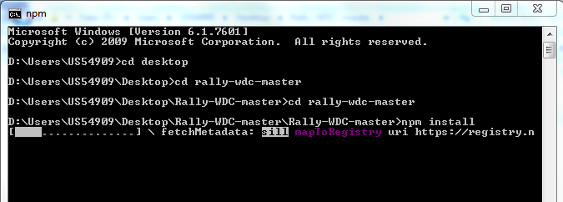

Now you are ready to run the project and are able to make live updates to the code and see the results of your changes in real time.

Run **npm run devstart**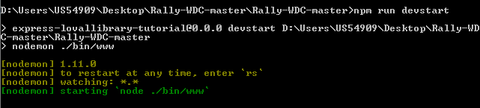

**Step: 2**

Now you are ready to configure the web data connector. Each rally user will have to configure the web data connector to be able to access data from there account to do this we visit rally’s development website and authenticate the Web data connector.

Since I have been developing with Jacobs account all his info is in the project already but if you want to connect with another user you will have to go through this process.

**First**

Go to

<https://rally1.rallydev.com/login/accounts/index.html#/clients>

And click on the create new client link which will bring you to this page 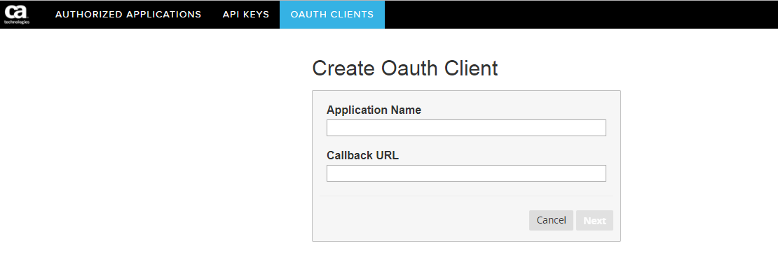

From here give the application a name and most importantly set the callback url to where you want to handle the callback request from rally when authenticating the user I have it set to **localhost:3000/redirect** you can see this in **line 87 of the app.js file** so input **localhost:3000/redirect in the callback URL**

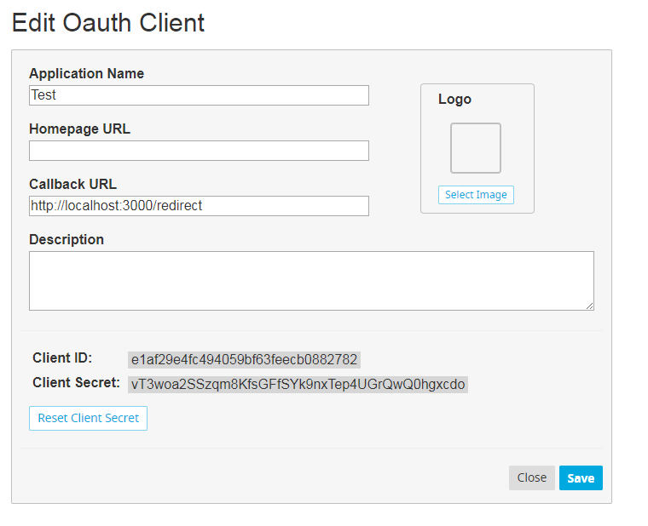Next we will need to record two very important codes. The client ID and the Client Secret ID these are both used during the authentication process.

You will then input these codes in the following places in the application

In the **config.js file**

In the **var config object** at the top of the **rallyWDC.js** file

Now you are ready to Run the application and can begin using and developing the web data connector